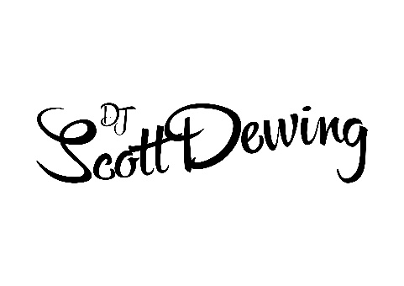
REQUEST SHEET
There is no limit to how many tracks you can add below but please keep in mind that on average a track is 3 minutes long which roughly gives me around 100 tracks to play on the night based on a 5 hour set (evening package).

MUST PLAY - If it got to the end of the night and you was gutted a track didn’t get played, whether it be a favourite song of a loved one that can’t be with you or a track that reminds you of an incredible memory – here’s the place to add it! Even if it is just a track that you absolutely love and want to hear– just pop it below:

PLAY IF POSSIBLE- This is where you could pop all those tracks you have heard on the radio that you love! I’ll be using this part of the list depending on the dancefloor – if I can think I can play it without losing you’re dancing guests – I’ll do my very best.

PLEASE AVOID – In the same way music can create great memories, it can also remind you of bad ones too (something I’d like to avoid on your big day) You don’t need to give me any reasons for these choices but as soon as they’re on the list, they won’t get played! You can include artists, tracks, genres or decades. Just be sure to give me some examples if you say ‘no cheese’ as everyone has a different opinion on what ‘cheesy’ music is – I’d just like to make sure we’re on the same page.

